Lab#01
Task#01:
network | networking
*set of computing devices connected together for the purpose of sharing information and resources  * a collection of computing devices connected together to communicate with each other | * total process of creating and using computer network , with respect to hardware,protocols,and software,including wired and wireless technology  *creating,maintaining and to other related activities involving a network

Task#02:
(2) Components of data communication model?
A data communication model, often referred to as a communication model or a communication system, consists of several key components that are essential for the transmission of data between sender and receiver. These components include:
- Sender: Initiates data transmission.
- Receiver: Receives the transmitted data.
- Message: The data to be transmitted.
- Transmission Medium: Path for data transfer.
- Protocol: Rules for data formatting and timing.
- Encoder and Decoder: Convert data for transmission and reception.
- Channel: Specific communication path in the medium.
- Noise: Unwanted interference affecting data quality.
- Feedback: Provides information on data reception and quality, aiding in error detection and correction.

Task#03:
(3) Does analogue conversation take place in source as transmitter?
Analog conversation can happen both at the source and during transmission. It occurs at the source when the original data is in analog form, such as voice or music. During transmission, the data may be converted into analog signals, but in many modern systems, it remains in digital form for more efficient and high-quality communication.

Task#04:
(4) Give an example of data communication model?
An example of data communication is the transfer of information from one device or system to another, such as sending an email from a computer to a mobile phone. The information is encoded into a digital format and sent through a network, such as the internet, to the intended recipient, who then decodes the information and can read or use it.

Task#05:
(5) What is Peer-to-Peer network?
A Peer-to-Peer (P2P) network is a type of computer network where all devices connected to the network have equal status and can communicate and share resources directly with one another. This contrasts with client-server networks, where a central server manages resources and client devices request services from it. In P2P networks, each node can both provide and consume resources, such as files, processing power, or services, without the need for a central server. These networks are often decentralized and can be used for various applications, including file sharing, distributed computing, and collaborative tasks. While they offer advantages like resilience and direct resource sharing, they can present challenges related to security and network management.

Task#06:
(6) Build LAN & WAN environment using Packet Tracer?
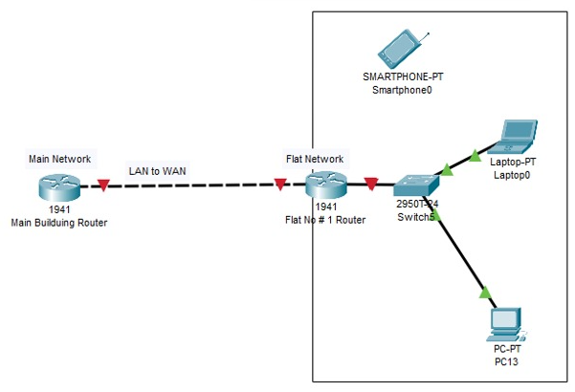
Lab#02

Task#01:
(1) What is difference between partial and full mesh topology?
Partial mesh and full mesh are both types of network topologies used in networking to determine how devices are interconnected. Here are the key differences between the two:
Partial Mesh Topology:
* Only some devices have direct connections to others.
* Reduces complexity and cost.
* Used when not every device needs direct communication with all others.
Full Mesh Topology:
* Every device has a direct connection to every other device.
* Provides high redundancy and fault tolerance.
* Common in critical communication environments where direct connections are essential.

Task#02:
(2) Design Bus and Star Topology environment using Packet Tracer?
